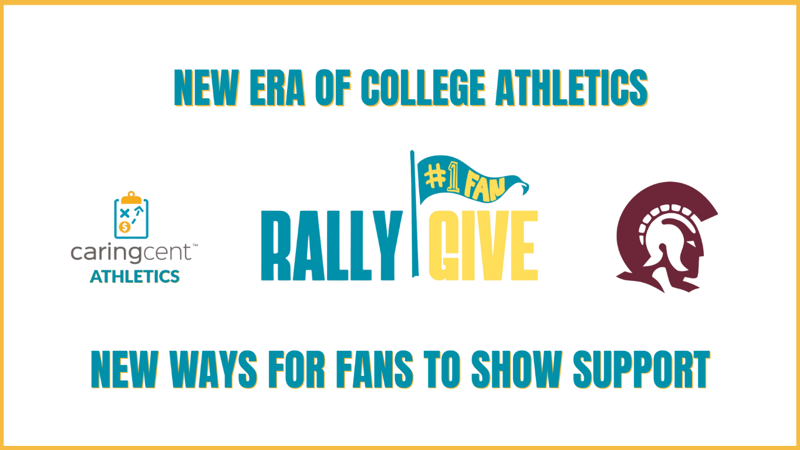

**FOR IMMEDIATE RELEASE**

**Little Rock and CaringCent Announce Partnership Focused on Optimizing In-season Development Efforts**

The University of Arkansas at Little Rock and CaringCent, the creator of *RallyGive*- the leading in-season fundraising solution for college athletic departments - have announced a partnership focused on unlocking new support throughout the athletic year.

Little Rock is the latest of a growing number of collegiate athletic departments to partner with CaringCent as leaders focus more than ever on opening new doors for fans to show support.

RallyGive has emerged as the leading in-season fundraising solution for college athletic departments and is uniquely built for today’s college sports landscape, where departments face increasing pressure to drive external revenue and engage previously untapped segments of fans and alumni.  The solution includes support from the expert CaringCent team, providing critical resources – in addition to technology – to optimize the impact of in season success.

“We are excited about the opportunities this partnership creates for Trojan fans to engage more deeply with our programs and directly support our efforts,” said Frank M. Cuervo, Little Rock Director of Athletics. “Today’s landscape requires us to continually innovate and the CaringCent team has developed an innovative approach that aligns perfectly with our mission and expands the ways in which our fans can get involved while strengthening the resources we provide to help our student-athletes succeed, on and off the field.”

Mario Moccia, Vice President of Business Development with CaringCent added, “In today’s fundraising environment, athletic departments face unprecedented pressure to identify new revenue streams and engage fans and alumni who haven’t traditionally contributed,” added Moccia.  "Innovative athletic departments on the rise, such as Little Rock are increasingly turning to RallyGive to offer their fans new dynamic and meaningful way to convert fans to donors and generate turnkey support for athletic programs.”

RallyGive’s model leverages peak emotional moments—game days, buzzer-beaters, record-setting plays - to prompt timely giving.  Its frictionless user experience removes barriers and makes contributing as easy as cheering from the stands.

For more information about RallyGive and CaringCent’s full suite of giving solutions, visit[www.caringcent.com](http:// www.caringcent.com) Mario Moccia can be reached at Mario@caringcent.com.